c.v.

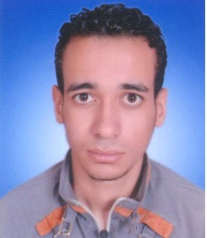
Personal Data

Name: | Hossam El-Dien Attia Emara Omr
Date and Place of Birth: | 5/6/1991,Assiut-Egypt
Nationality: | Egyptian
Institute: | Chemistry Department, Faculty of Science, Assiut University, Assuit, 71516 Egypt
Telephone: | 00201000848570 (Mobil)
Current Position: | Demonstrator
Marital status: | single
Fields of Research: | Computational Chemistry
E-mail: | hossamlec_aunche@yahoo.com

Education and Academic Qualifications:

2012 : Bachelor of Chemistry, Faculty of Science, Assiut University, Very good with honour grade .
2013 until present: Demonstrator, Chemistry Department, Faculty of Science, Assiut University.

